Assignment-3

Assignment 3: Utilize a subquery to find customers who have placed orders above the average order value, and write a UNION query to combine two SELECT statements with the same number of columns.


Subquery:

- Customers Who Have Placed Orders Above the Average Order Value using Subquery.
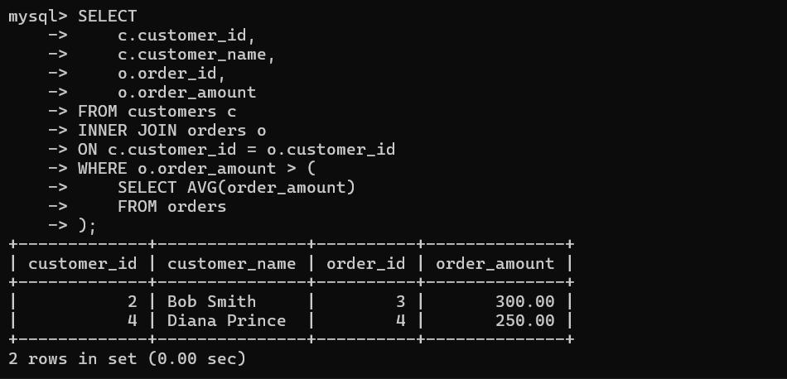

UNION Query:

- The first query fetches details of customers from the "West" region.

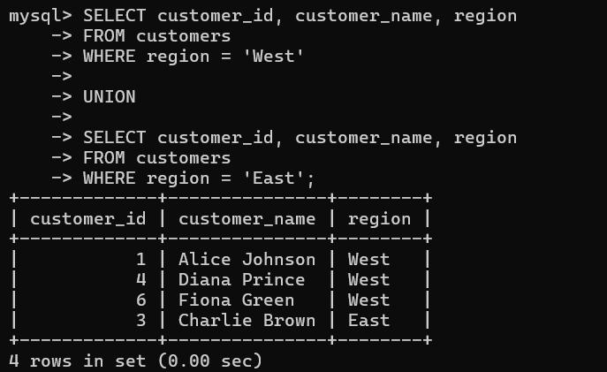
- The second query fetches details of customers from the "East" region.

